Distributed and Parallel Computing for Big Data, Cloud Computing and Big Data, In-Memory Computing Technology for Big Data, Introduction to Hadoop, HDFS, MapReduce, YARN, HBase, Combining HDFS and HBase

<https://www.youtube.com/watch?v=1Vo3M09zD94>

Distributed and Parallel Computing for Big Data

Distributed and parallel computing are two important paradigms used for processing large datasets in big data environments. While they share some similarities, they have distinct characteristics and are used in different contexts based on the nature of the task, data distribution, and computing environment. Let's explore each paradigm in detail and then compare them.

## ****Distributed Computing****

### Overview:

* **Definition**: Distributed computing involves using multiple computers, often geographically dispersed, working together to complete a single task. Each node (computer) in the distributed system is independent but coordinates with others through message passing.
* **Architecture**: Typically involves a network of interconnected machines that communicate over a network (e.g., cluster computing, cloud computing).
* **Data Distribution**: Data is split across multiple nodes, and each node performs its computation on its local dataset.
* **Fault Tolerance**: High fault tolerance, as failure in one node usually doesn't halt the entire process; other nodes can continue processing.
* **Use Cases**: Suitable for applications where the dataset is too large to fit on a single machine, like data storage (e.g., Hadoop HDFS) or large-scale computations (e.g., MapReduce).

### Key Characteristics:

* Nodes have their own memory and CPUs.
* Communication between nodes is done via network messages.
* Can involve heterogeneous hardware.

## ****Parallel Computing****

### Overview:

* **Definition**: Parallel computing involves performing multiple operations simultaneously using multiple processors within a single machine or a tightly-coupled system.
* **Architecture**: Usually uses a shared memory or multicore architecture (e.g., multicore CPUs, GPUs, supercomputers).
* **Data Distribution**: The dataset is divided into smaller chunks and distributed among processors for simultaneous processing.
* **Fault Tolerance**: Lower fault tolerance compared to distributed computing, as all processors are part of the same system. A failure in one processor can impact the entire computation.
* **Use Cases**: Ideal for scientific computations, matrix operations, simulations, and other tasks that require concurrent operations.

### Key Characteristics:

* Processors have access to shared memory.
* Communication is through shared memory instead of messages.
* Works with homogeneous hardware.

## ****Comparison: Distributed vs. Parallel Computing****

| **Criteria** | **Distributed Computing** | **Parallel Computing** |
| --- | --- | --- |
| **Definition** | Multiple independent computers working together | Multiple processors in a single machine working together |
| **Architecture** | Cluster of computers connected over a network | Multi-core, GPU, or shared memory systems |
| **Communication** | Via message passing over the network | Via shared memory |
| **Data Handling** | Large datasets distributed across nodes | Datasets split into chunks processed in parallel |
| **Scalability** | Highly scalable by adding more nodes | Limited by the number of cores/processors in a system |
| **Fault Tolerance** | High, as nodes are independent | Low, as failure in one core can disrupt the entire process |
| **Use Cases** | Big data processing, distributed databases, cloud computing | Scientific computing, real-time simulations, graphics |
| **Examples** | Apache Hadoop, Apache Spark, AWS EMR | OpenMP, CUDA, Intel TBB |
| **Overhead** | High communication and coordination overhead | Low communication overhead |
| **Task Type** | Suitable for loosely coupled tasks | Suitable for tightly coupled tasks |
| **Execution Environment** | Can run on geographically distributed machines | Runs on a single machine or a tightly coupled environment |

### ****When to Use Which?****

**Distributed Computing** is ideal for:

* + Processing and analyzing extremely large datasets (e.g., big data analytics).
  + Applications that can be split into independent tasks.
  + Scenarios requiring scalability and fault tolerance (e.g., distributed databases, cloud services).

**Parallel Computing** is best suited for:

* + Tasks requiring high-speed computations with low latency.
  + Applications that need shared memory access (e.g., simulations, real-time graphics).
  + Computations that can leverage specialized hardware (e.g., GPU for machine learning).

Both paradigms can be combined in some scenarios (e.g., distributed parallel computing in HPC or hybrid cloud environments), depending on the computational needs and data distribution requirements.

Cloud Computing and Big Data

<https://www.geeksforgeeks.org/difference-between-big-data-and-cloud-computing/>

In-memory computing technology is a modern approach used to overcome the limitations of traditional disk-based data processing systems, especially for big data analytics and real-time applications. By storing entire datasets in the main memory (RAM) instead of slower disk storage, in-memory computing drastically reduces latency and speeds up data processing. This technology is particularly advantageous for big data workloads where speed, scalability, and low-latency access are critical.

## ****What is In-Memory Computing?****

In-memory computing is the technique of processing data stored in the RAM of multiple machines rather than on disk storage. This allows for significantly faster read and write times because memory (RAM) access is orders of magnitude faster than disk access. It is widely used in big data environments for real-time data analytics, transaction processing, and complex data manipulation.

### Key Concepts:

1. **RAM Storage**: All the data is loaded and processed directly in the RAM instead of being read from the disk, resulting in minimal latency.
2. **Distributed Cache**: Data is often stored in a distributed in-memory data grid (IMDG) across multiple nodes, enabling large-scale processing.
3. **Parallel Processing**: In-memory systems often incorporate parallel processing techniques to leverage multi-core processors for concurrent data access and analysis.
4. **Scalability**: Nodes can be easily added to the cluster, allowing in-memory platforms to handle increasing data volumes without compromising performance.

## ****Benefits of In-Memory Computing for Big Data****

**High Speed and Low Latency**:

* 1. Data retrieval and processing times are significantly lower since data is stored in volatile RAM rather than disk.
  2. Suitable for real-time analytics, fraud detection, recommendation engines, and high-frequency trading.

**Real-Time Analytics**:

* 1. Supports real-time or near-real-time data analytics and decision-making.
  2. Queries and computations that took hours with traditional systems can now be performed in seconds.

**Simplified Architecture**:

* 1. Eliminates the need for complex data-loading mechanisms, reducing ETL overhead and simplifying the data pipeline.

**Scalability**:

* 1. Easily scale horizontally by adding more nodes to the in-memory grid, allowing the system to handle petabytes of data in real-time.

**Reduced Disk I/O Bottlenecks**:

* 1. Eliminates the frequent read-write operations to and from disk, reducing I/O bottlenecks.

## ****In-Memory Computing Technologies****

Several platforms and frameworks are specifically designed for in-memory computing. Some prominent technologies include:

**Apache Spark**:

* 1. A powerful, open-source framework for large-scale data processing and machine learning.
  2. Features an in-memory computation model that caches intermediate data in memory to reduce computation times.
  3. Suitable for iterative algorithms, real-time data processing, and machine learning workloads.

**Apache Ignite**:

* 1. An in-memory data grid and computing platform for distributed data processing.
  2. Supports advanced data structures, in-memory SQL, and ACID transactions.
  3. Can be used as a caching layer or a standalone in-memory computing solution.

**Hazelcast**:

* 1. A distributed in-memory data grid for processing large datasets.
  2. Provides high availability, low latency, and distributed computing capabilities.
  3. Often used for real-time data processing, in-memory caching, and data sharing across distributed systems.

**SAP HANA**:

* 1. An in-memory, column-oriented, relational database management system.
  2. Optimized for high-speed transactions and analytics on real-time data.
  3. Often used for ERP, finance, and supply chain management.

**Redis**:

* 1. A high-performance in-memory key-value data store.
  2. Offers data persistence and replication for high availability.
  3. Suitable for real-time analytics, caching, and message brokering.

**Memcached**:

* 1. A general-purpose distributed memory caching system.
  2. Used to speed up dynamic web applications by caching database calls.

**Oracle TimesTen**:

* 1. An in-memory relational database optimized for high-speed data management and OLTP (Online Transaction Processing).
  2. Offers real-time analytics and high availability.

## ****Use Cases for In-Memory Computing in Big Data****

**Real-Time Data Analytics**:

* 1. Analyze streaming data in real-time for insights, anomaly detection, and predictive analytics.
  2. Use cases include IoT sensor data processing, financial market analysis, and customer behavior tracking.

**Machine Learning and AI**:

* 1. Train and execute machine learning models on large datasets stored in memory.
  2. Applications include recommendation engines, fraud detection, and personalized services.

**High-Speed Transactions**:

* 1. Handle large volumes of transactions with low latency.
  2. Commonly used in banking, e-commerce, and online gaming industries.

**Complex Event Processing (CEP)**:

* 1. Detect patterns, correlations, and anomalies in high-frequency data streams.
  2. Applications include network monitoring, cybersecurity, and real-time decision support systems.

**In-Memory Caching**:

* 1. Use in-memory data grids for distributed caching to speed up data retrieval and reduce database load.
  2. Useful in scenarios where frequent read operations are required, such as web session management.

## ****Challenges of In-Memory Computing****

1. **Cost**: RAM is significantly more expensive than traditional disk storage, leading to higher infrastructure costs.
2. **Volatility**: RAM is volatile, so a power failure or crash can lead to data loss unless the data is backed up or replicated.
3. **Scalability Issues**: While scaling horizontally is possible, managing a large-scale in-memory cluster requires specialized tools and expertise.
4. **Data Consistency**: In-memory computing systems may face challenges in maintaining data consistency across distributed nodes, especially in write-heavy scenarios.

## ****Conclusion****

In-memory computing is a powerful technology for big data environments, enabling real-time analytics, high-speed computations, and low-latency access to data. While it offers substantial performance benefits, it comes with increased costs and complexity, making it suitable for use cases where speed is critical and latency cannot be tolerated. Combining in-memory computing with traditional disk-based storage can often provide a balanced solution for diverse big data workloads.

Hadoop

<https://www.javatpoint.com/what-is-hadoop>

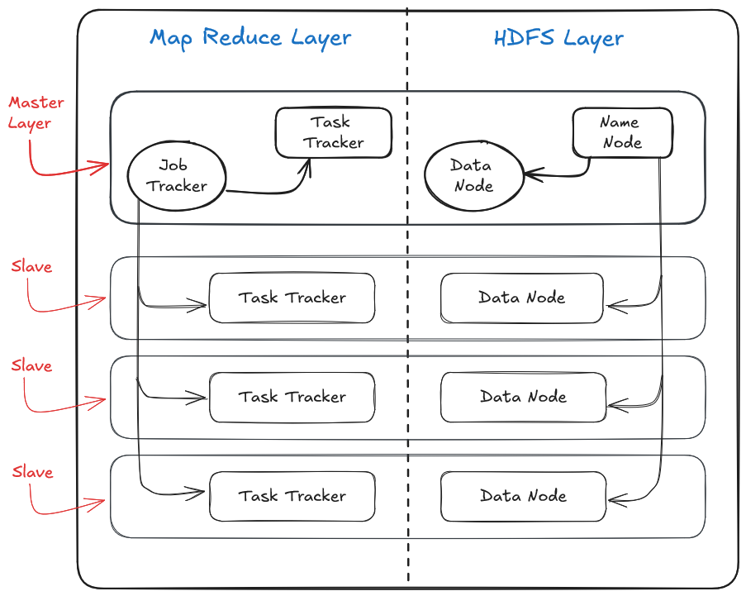

Hadoop is a framework that enables the distributed processing of large datasets across clusters of computers using simple programming models. It is designed to scale up from a single server to thousands of machines, each offering local computation and storage. Hadoop's architecture is based on two core components: **HDFS (Hadoop Distributed File System)** and **MapReduce**. The system operates on a master-slave architecture.

### Key Points of Hadoop Architecture:

#### 1. ****HDFS (Hadoop Distributed File System) Layer:****

* HDFS is a distributed file system that stores data across multiple nodes in the Hadoop cluster.
* It is designed to handle large volumes of data by splitting it into blocks and distributing them across multiple nodes.
* HDFS consists of two main components:
  + **NameNode** (Master Node): Manages the metadata of all the files and directories, such as the file system tree, file permissions, and the location of blocks.
  + **DataNodes** (Slave Nodes): Store the actual data blocks. Each DataNode is responsible for serving read and write requests from clients.

#### 2. ****MapReduce Layer:****

* MapReduce is a programming model used for processing and generating large datasets.
* It consists of two main phases:
  + **Map Phase**: Processes input data and produces a set of intermediate key-value pairs.
  + **Reduce Phase**: Aggregates the intermediate results and produces the final output.
* The MapReduce layer also has a master-slave architecture:
  + **Job Tracker** (Master Node): Manages resources, job scheduling, and monitors task progress.
  + **Task Trackers** (Slave Nodes): Executes individual tasks as per instructions from the Job Tracker.

#### 3. ****Master Node:****

* A single master node is present in the cluster, responsible for managing and coordinating the entire Hadoop system.
* The master node runs the following components:
  + **NameNode** (HDFS Layer): Manages metadata and controls access to files.
  + **Job Tracker** (MapReduce Layer): Manages and schedules jobs for processing data.

#### 4. ****Slave Nodes:****

* Multiple slave nodes are present in a Hadoop cluster.
* Each slave node runs the following components:
  + **DataNode** (HDFS Layer): Stores data blocks and reports to the NameNode.
  + **Task Tracker** (MapReduce Layer): Executes the tasks assigned by the Job Tracker.

### Layered Architecture:

**HDFS Layer:**

* + Manages the distributed storage of data.
  + Data is split into blocks and stored across DataNodes, ensuring fault tolerance and high availability.

**MapReduce Layer:**

* + Manages the distributed processing of data.
  + Splits the computation into small tasks that run in parallel across the cluster.

### Workflow Summary:

**Data Storage in HDFS:**

* + When a file is stored in HDFS, it is divided into smaller blocks (e.g., 128 MB each) and distributed across DataNodes.
  + The NameNode maintains metadata about where each block is stored.

**Data Processing with MapReduce:**

* + When a job is submitted, the Job Tracker splits the task into smaller units (Map and Reduce tasks) and distributes them to Task Trackers on slave nodes.
  + Each Task Tracker processes its portion of the data and sends the results back to the Job Tracker, which aggregates the results to produce the final output.

This layered approach allows Hadoop to efficiently store and process massive datasets with fault tolerance, scalability, and parallelism.

HDFS

HDFS stands for **Hadoop Distributed File System**. Let me break it down step-by-step in simple terms:

### 1. ****What is HDFS?****

Think of HDFS as a **giant digital storage system**. It's like a huge library where you store files, but instead of being on a single computer, the files are spread across **many computers** working together.

It was created to handle **very large amounts of data** and make sure that even if some computers fail, the data is still safe and available.

### 2. ****How does HDFS work?****

Imagine you have a huge book that doesn’t fit on a single shelf. So, you break it into chapters and store those chapters on different shelves. Similarly, in HDFS:

* **Large files** are divided into **smaller chunks (blocks)**.
* These chunks are **distributed across multiple computers** (called nodes) in the cluster.

### 3. ****Why is HDFS special?****

HDFS has **three key features**:

**Fault Tolerance (No Data Loss):**

* + Every piece of data (block) is stored in **multiple places** (usually 3 copies).
  + If one computer crashes, no problem! The system can pull the data from another copy on a different computer.

**Scalable (Can Grow with Time):**

* + You can **add more computers** to store more data, just like adding more shelves to your library.
  + It’s perfect for companies that need to store **tons of data** and keep growing.

**Distributed Access (Faster Reading):**

* + Since the data is spread across many computers, multiple people can access it **at the same time** without slowing things down.

### 4. ****Key Components of HDFS****

**NameNode:**  
Think of it as the **librarian**. It knows where all the data is stored in the cluster but **doesn’t store the data itself**.

**DataNodes:**  
These are the **shelves** where the actual data chunks (blocks) are stored. Each computer that stores these chunks is called a **DataNode**.

### 5. ****How Data is Saved in HDFS (Example)****

Let’s say you want to store a 600MB video in HDFS. If the block size is 128MB, the system will break it like this:

* **Block 1:** 128MB
* **Block 2:** 128MB
* **Block 3:** 128MB
* **Block 4:** 128MB
* **Block 5:** 88MB (remaining part)

These 5 blocks are stored **on different computers** across the cluster. To ensure safety, HDFS makes **copies** of each block (usually 3 copies) and stores them on other machines.

### 6. ****Why Use HDFS?****

HDFS is perfect when you need to store and process **huge amounts of data** that can’t fit on a single computer. It’s widely used by companies like Google, Facebook, and Amazon to manage their massive datasets.

### 7. ****Limitations of HDFS****

* **Not great for small files:** It’s designed for large files, and storing millions of tiny files can slow things down.
* **High network use:** Since data is spread across many computers, it can use a lot of network bandwidth.
* **Batch processing focus:** It works best for big jobs that process data in batches (like analyzing large datasets), not for quick, real-time data updates.

In short, **HDFS is like a giant library** spread across many computers. It ensures data is **safe, easily accessible, and scalable**—perfect for managing large amounts of information.

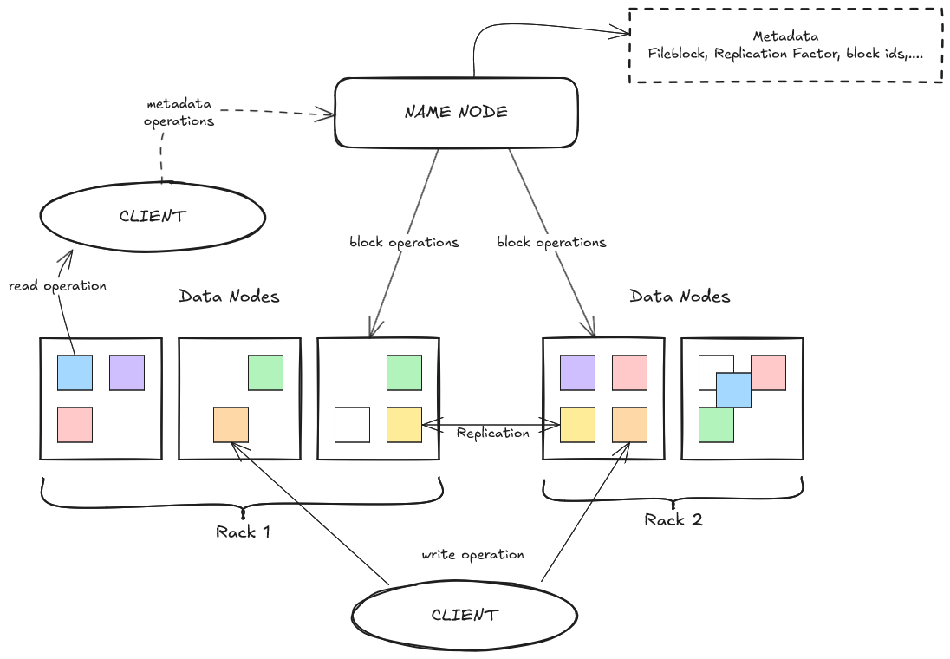

### 1. ****HDFS Components: NameNode and DataNode****

HDFS is like a **library system** with two main types of workers:

**NameNode (Master):**

* 1. This is like the **head librarian**. It keeps track of where every part of your files (called blocks) is stored on different shelves (DataNodes).
  2. **Stores metadata** (information about files, directories, and blocks), but it doesn’t store the actual data itself.
  3. It ensures the system knows where to find each file’s chunks when needed.

**DataNode (Slave):**

* 1. These are like the **shelves** that store the actual **data blocks**.
  2. Each computer (DataNode) stores and manages several blocks of data and reports back to the NameNode regularly.

### 2. ****Master-Slave Architecture****

HDFS follows a **Master-Slave Architecture**:

* **Master**: The **NameNode** is the master, responsible for managing metadata and coordinating the entire cluster.
* **Slaves**: The **DataNodes** are the workers or slaves, storing and managing the actual data.

The NameNode instructs the DataNodes on how and where to store data blocks. The system depends on constant communication between these components.

### 3. ****File System Namespace****

This is the **hierarchical structure** of files and directories, similar to how a computer organizes files into folders. Think of it as the **catalog** the NameNode maintains, showing where all the files are stored, much like a library catalog showing where each book is.

### 4. ****File Blocks****

* In HDFS, **large files are split into smaller pieces** called **blocks**. Each block is typically **128MB** (though this can be configured).
* These blocks are spread across different DataNodes to **distribute the load** and ensure **high availability**.

### 5. ****File System Clients****

Clients are the **users or applications** that interact with HDFS. They **upload**, **download**, or **modify files** on the system by contacting the NameNode and DataNodes.

Examples of clients include:

* Command-line interface (CLI) users
* Applications like Hive, Spark, or MapReduce jobs

### 6. ****Client Operations: Read, Write, and Metadata Operations****

Here’s how a typical **read and write operation** works:

**Write Operation:**

* 1. The client asks the **NameNode** where to store the new file’s blocks.
  2. The NameNode returns a list of **DataNodes** that can store the data.
  3. The client sends the data to these DataNodes, and it’s broken into blocks and stored across them.

**Read Operation:**

* 1. The client asks the **NameNode** where a file’s blocks are stored.
  2. The NameNode provides the addresses of the DataNodes containing those blocks.
  3. The client retrieves the data directly from the DataNodes.

**Metadata Operations:**  
When the client needs to **create, rename, delete, or modify files**, these operations are **handled by the NameNode**, which updates the file system namespace.

### 7. ****HDFS is Built Using Java****

HDFS is **written in Java**. It’s a part of the larger **Hadoop ecosystem**. Because Java is platform-independent, HDFS can run on different operating systems and hardware platforms.

### 8. ****Data Replication in HDFS****

To ensure data is **safe and available**, HDFS **replicates blocks** multiple times (usually 3 copies). This process ensures that even if some DataNodes fail, the data is not lost.

* **Blocks and Block Size:** Files are divided into **128MB blocks** by default.
* **Replication Factor:** Each block is **copied (replicated)** across **multiple DataNodes** (typically 3 copies).
* **Heartbeat:** DataNodes **send heartbeats to the NameNode** periodically to confirm that they are active and healthy.
* **BlockReport:** DataNodes periodically send a **BlockReport** to the NameNode, listing all the blocks they store.

### 9. ****Replica Placement Policy****

**HDFS uses a special policy** for placing replicas to ensure data safety and performance:

**Rack-Aware Replica Placement Policy:**

* + In large data centers, computers are organized into **racks** (groups of machines connected to the same network switch).
  + To **reduce network congestion**, HDFS tries to store replicas of a block **across different racks**.
  + This way, even if a whole rack fails, other copies are available from different racks.

**Hadoop Rack Awareness:**

* + The NameNode is **aware of the rack structure** in the cluster.
  + When placing replicas, it tries to place:
    1. **One copy on the same rack as the client (locality improves speed).**
    2. **Two copies on a different rack.**
    3. **Third copy on yet another rack (for fault tolerance).**

In summary, **HDFS distributes files across many computers** by breaking them into **blocks** and placing multiple copies (replicas) for **fault tolerance**. The **NameNode keeps track of the blocks** (metadata), while the **DataNodes store the actual data**. HDFS ensures high availability through **data replication**, **rack-aware placement policies**, and constant **heartbeat communication** between NameNode and DataNodes.

## ****Features of HDFS****

**Distributed Storage:**

* 1. Files are divided into **blocks** and distributed across multiple machines (DataNodes).

**Fault Tolerance:**

* 1. **Data replication** ensures data safety. If one machine fails, another copy is available from another DataNode.

**Scalability:**

* 1. HDFS can easily **scale horizontally** by adding more DataNodes to the cluster.

**High Throughput:**

* 1. HDFS is optimized for **batch processing** (large-scale data reads and writes). It can handle high data transfer rates for large files.

**Replication for Data Safety:**

* 1. The **default replication factor** is 3, meaning each block is stored on 3 different machines for redundancy.

**Rack Awareness:**

* 1. HDFS uses **rack-aware replica placement** to ensure better fault tolerance and optimize network traffic.

**Write Once, Read Many Model:**

* 1. Data written to HDFS is **immutable** (cannot be changed). Once written, it can only be read multiple times, making it ideal for large datasets and log analysis.

**Support for Large Files:**

* 1. HDFS can store **massive files** (even in petabytes) by distributing the blocks across multiple machines.

**Java-based and Cross-platform:**

* 1. HDFS is built using **Java**, making it platform-independent and easy to deploy on various operating systems.

**Seamless Integration with Hadoop Ecosystem:**

* Works smoothly with tools like **MapReduce, Hive, Spark, and Pig**, enabling advanced data processing.

## ****Advantages of HDFS****

**High Availability:**

* + Even if multiple nodes fail, **replication** ensures that data is always available.

**Cost-Effective:**

* + HDFS runs on **commodity hardware**, which reduces costs compared to using expensive storage systems.

**Fault Tolerance:**

* + **Replication and heartbeat** mechanisms ensure data integrity even if hardware fails.

**Handles Big Data Efficiently:**

* + HDFS is designed to handle **massive amounts of data**, making it ideal for large organizations and data-intensive applications.

**Horizontal Scalability:**

* + The system can **grow** as data needs increase by adding more nodes, without requiring system redesign.

**Optimized for Large Files:**

* + Large datasets are **broken into blocks** and stored across the cluster, allowing for parallel data processing.

**Data Locality Optimization:**

* + HDFS ensures that **computation happens close to the data** to minimize network traffic, enhancing performance.

**Batch Processing Efficiency:**

* + Works well with **MapReduce** and other batch processing frameworks, making it ideal for large-scale data processing tasks.

## ****Limitations of HDFS****

**Not Ideal for Small Files:**

* + Storing many **small files** can overload the NameNode since it stores metadata for every file and block.

**Single Point of Failure (SPOF):**

* + The **NameNode** is a critical component. If it fails, the entire system becomes inaccessible unless configured with a **backup NameNode**.

**High Latency for Random Access:**

* + HDFS is not suitable for **real-time data access** because it’s optimized for sequential reads and writes, not random reads.

**Write-Once, Read-Many:**

* + Data once written to HDFS **cannot be modified**. This limits use cases where frequent data updates are needed.

**High Network Usage:**

* + Data replication and distributed architecture can lead to **high network traffic**, especially when dealing with large files.

**Overhead for Metadata Storage:**

* + The NameNod stores **all metadata in memory**, which can become a bottleneck when dealing with millions of files and blocks.

**Complex Configuration and Management:**

* + Setting up and maintaining an HDFS cluster can be **challenging**, requiring knowledge of distributed systems and networking.

**Not Suitable for Low Latency Applications:**

* + HDFS is better for **batch processing** rather than **real-time** or transactional systems where low latency is required.

In summary, **HDFS excels in storing and processing huge datasets efficiently** by distributing data across multiple nodes with built-in fault tolerance. However, it comes with some trade-offs, such as **poor performance with small files** and **high reliance on the NameNode**. It is best suited for **large-scale data processing** tasks rather than applications requiring frequent updates or real-time access.

MapReduce

### ****What is MapReduce?****

MapReduce is a **programming model** used in **Hadoop** to process large datasets in a **distributed and parallel** manner. It breaks down a big task into smaller sub-tasks that can run simultaneously on different machines. It consists of two major stages: **Map** and **Reduce**.

## ****How MapReduce Works?****

Think of it like **sorting exam papers**:

* First, you split the exam papers into **groups** by subjects (this is the **Map** stage).
* Then, each subject’s marks are **summed up** to get the total for that subject (this is the **Reduce** stage).

## ****Key Components of MapReduce****

### 1. ****Map Phase****

**Input:** The input data is **split** into chunks (called input splits).

**Mapper Task:** The **mapper** function processes each chunk independently and generates **key-value pairs** as output.

**Example:** If we’re counting words in a text, the mapper would output each word with a count of **1** (e.g., ("Hadoop", 1), ("Data", 1)).

**Output:** A set of key-value pairs, like:

("Hadoop", 1), ("Data", 1), ("Hadoop", 1)

### 2. ****Shuffle and Sort Phase****

After the **map phase**, Hadoop **groups the key-value pairs by key**.

* All identical keys are sent to the **same reducer** for processing.
* This step ensures that all data related to a specific key (e.g., “Hadoop”) is collected together, no matter which mapper generated it.

**Example Output after Shuffle and Sort:**

("Hadoop", [1, 1]), ("Data", [1])

### 3. ****Reduce Phase****

* **Reducer Task:** Each **reducer** processes a group of key-value pairs, performs some computation (like summing counts), and produces the final result.
* **Example:** The reducer sums all the values for “Hadoop”:

("Hadoop", 2), ("Data", 1)

### 4. ****Final Output****

The final result of the **reduce phase** is written to the **HDFS**. For our word count example, the output could look like:

Hadoop 2

Data 1

## ****Components of MapReduce in Hadoop****

**InputFormat**

* + Defines **how input files are split** and fed to the mappers.
  + Common types: **TextInputFormat** (for text files), **KeyValueTextInputFormat** (for key-value pairs).

**Mapper**

* + A function that takes **input data** and transforms it into key-value pairs.

**Partitioner**

* + Decides **which reducer** will receive which key-value pair. It ensures that all values associated with a given key go to the **same reducer**.

**Shuffle and Sort**

* + A **data transfer step** where intermediate data (key-value pairs from the mapper) is shuffled and sorted before being sent to the reducer.

**Reducer**

* + Processes **all values for a given key** and produces the final output.

**OutputFormat**

* + Defines how the **output data** is written to HDFS. Common types include **TextOutputFormat**.

**Job Tracker (Master Node)**

* + **Coordinates the entire MapReduce job**, schedules tasks, and monitors progress (in Hadoop 1.x). In Hadoop 2.x, the **ResourceManager** takes over this role.

**Task Tracker (Slave Nodes)**

* + Executes **mapper and reducer tasks** on individual nodes in Hadoop 1.x. In Hadoop 2.x, it is replaced by **NodeManagers**.

## ****Advantages of MapReduce****

**Parallel Processing:**

* + Tasks run on multiple nodes simultaneously, speeding up processing.

**Fault Tolerance:**

* + If a node fails, the task is automatically **re-executed** on another node.

**Scalable:**

* + MapReduce can handle **petabytes of data** by distributing the workload across many machines.

**Data Locality:**

* + **Computation happens close to the data** (on the same node), reducing network traffic.

**Simple Programming Model:**

* + Developers only need to write the **map and reduce functions**, and Hadoop handles the rest (shuffling, sorting, etc.).

## ****Limitations of MapReduce****

**Not Real-Time:**

* + It is designed for **batch processing**, meaning it works best for tasks that don’t require instant results.

**High Latency:**

* + The shuffling and sorting phases can introduce **delays**.

**Complex for Small Tasks:**

* + For smaller datasets, MapReduce’s overhead (splitting, shuffling, etc.) can be unnecessary and slow.

**Difficult to Debug:**

* + Debugging distributed applications can be **challenging**, as failures might occur on multiple nodes.

**Limited Flexibility:**

* + MapReduce works well for certain types of problems (like word counting), but more complex operations can require **multiple jobs** to chain together.

## ****In Summary****

MapReduce is an essential **data processing framework in Hadoop**, breaking down large tasks into smaller, independent tasks that run in **parallel**. Its **mapper, shuffle, and reducer components** ensure data is processed efficiently, with **fault tolerance** and scalability built-in. However, it is not suited for **real-time processing** and can introduce overhead for smaller tasks.

### ****1. HDFS is for Storing Big Data and MapReduce is for Processing Big Data****

* **HDFS (Hadoop Distributed File System)** is responsible for **storing large datasets** across many nodes in a distributed manner. It breaks files into large blocks (typically 128MB or 256MB) and distributes these blocks across multiple machines (DataNodes).
* **MapReduce** is a **data processing model** used to **analyze and process** the data stored in HDFS. It allows parallel processing of large datasets by splitting the work into multiple smaller tasks that run across the cluster.

In simple terms, HDFS is like a **warehouse** for storing vast amounts of data, while MapReduce is like a **factory** that processes the data stored in that warehouse.

### ****2. Map Tasks (or Functions) and Reduce Tasks (or Functions)****

* **Map Task (Mapper Function):**
  + The **map task** is the first step in the MapReduce process.
  + It takes input data, processes it, and **transforms it into intermediate key-value pairs**.
  + **Example:** If processing a large text file, the map function could count occurrences of each word, outputting key-value pairs like ("word", 1) for each word.
* **Reduce Task (Reducer Function):**
  + The **reduce task** comes after the mapping phase.
  + It takes the intermediate key-value pairs produced by the mapper, **groups** all values by key, and **aggregates** them.
  + **Example:** If the mapper produced pairs like ("word", 1), the reducer would sum all occurrences of the same word to produce ("word", total_count).

### ****3. Inputs and Outputs of Map and Reduce Tasks****

**Map Task Input:**

* + The input to the map task comes from **HDFS**. It could be files, logs, or large datasets split into **chunks (input splits)**.
  + Input is typically processed as **key-value pairs**, where the key could be something like a file offset, and the value could be a line of text.

**Map Task Output:**

* + The output of the map task is a set of **intermediate key-value pairs**.
  + Example: For a word count problem, the mapper could output pairs like ("Hadoop", 1), ("BigData", 1).

**Reduce Task Input:**

* + The reduce task receives the **sorted intermediate key-value pairs** from the map tasks, grouped by the key.
  + Example: If the mapper produced pairs for the word "Hadoop," the reduce task would receive something like ("Hadoop", [1, 1, 1]).

**Reduce Task Output:**

* + The final output is stored in **HDFS** and could be a summary or aggregated result.
  + Example: The reducer would output ("Hadoop", 3) for the word "Hadoop" if it appeared 3 times in the input.

### ****4. Compute Node (MapReduce Framework) and Storage Node (HDFS) on the Same Set of Nodes****

* In a Hadoop cluster, both **HDFS and MapReduce** typically run on the same nodes (machines).
* **Why is this beneficial?**
  + This allows the MapReduce framework to **schedule tasks** on nodes that already contain the required data (data locality), minimizing the need to transfer large datasets across the network.
  + This configuration ensures **high aggregate bandwidth**, meaning the cluster can process data quickly and efficiently because **computation happens close to where the data is stored**.

### ****5. Master-Slave Architecture in MapReduce****

**Job Tracker (Single Master)**:

* + The **Job Tracker** is the **master node** responsible for coordinating the entire MapReduce job.
  + It **splits the job into tasks** and assigns them to worker nodes (Task Trackers).
  + It **monitors task completion**, **handles failures**, and **reschedules tasks** if any nodes fail.
  + The Job Tracker was used in **Hadoop 1.x**; in **Hadoop 2.x**, it was replaced by **ResourceManager** in YARN.

**Task Tracker (Multiple Slaves)**:

* + The **Task Trackers** are the **worker nodes** in the cluster.
  + Each Task Tracker is responsible for **running map and reduce tasks** assigned by the Job Tracker.
  + Task Trackers also **send progress reports** and **heartbeat signals** to the Job Tracker to indicate their health and task status.
  + If a task fails, the Job Tracker will assign it to another Task Tracker.

In **Hadoop 2.x**, Task Trackers were replaced by **NodeManagers**, and the scheduling responsibility was moved to the **YARN ResourceManager**.

### ****6. MapReduce Framework Operates Exclusively on <Key, Value> Pairs****

* The entire MapReduce framework is based on **key-value pairs**:
  + **Mapper Input and Output**: Both input to the mapper and its output are **key-value pairs**. The mapper transforms the input into intermediate key-value pairs.
  + **Reducer Input and Output**: The reducer takes the intermediate key-value pairs produced by the mapper, processes them, and produces a final set of key-value pairs as output.

In essence, everything in MapReduce, whether it’s input, intermediate data, or final output, is represented as **<key, value> pairs**.

### ****Additional Components of MapReduce You Missed:****

**InputFormat:**

* + Defines how **input data** is split and read by the MapReduce program. Common types include:
    - **TextInputFormat** (for processing text files).
    - **KeyValueInputFormat** (for key-value structured data).

**OutputFormat:**

* + Defines how **output data** is written to HDFS after the reduce phase. Common types include:
    - **TextOutputFormat** (writes output as text files).
    - **SequenceFileOutputFormat** (writes binary output for more efficient storage).

**Partitioner:**

* + The **partitioner** controls the **distribution of the key-value pairs** produced by the mapper across the different reducers.
  + For example, it ensures that all values for the same key are sent to the **same reducer**.

**Combiner:**

* + The **combiner** is an optional mini-reducer that runs **on the map side** before sending data to the reducer.
  + It helps **optimize performance** by reducing the amount of data transferred between map and reduce tasks (e.g., local aggregation of key-value pairs).

**Shuffle and Sort:**

* + This phase **sorts and shuffles the intermediate data** produced by the mappers, grouping it by key, and sends it to the appropriate reducers.
  + The shuffle and sort step is **critical** because it ensures that all data related to the same key is grouped together for processing by the reducer.

### ****In Summary:****

* **HDFS** stores the data, while **MapReduce** processes it by breaking down the job into **map tasks** and **reduce tasks**.
* **Mapper tasks** process the data in parallel and produce **key-value pairs**, while **Reducer tasks** aggregate these key-value pairs.
* The MapReduce framework runs on a **master-slave architecture**, with the **Job Tracker** (master) and **Task Trackers** (slaves).
* The framework exclusively operates on **<key, value> pairs**, allowing it to efficiently handle and process large-scale datasets in a distributed environment.

### ****MapReduce Architecture/Implementation for Word Count Example****

Let’s walk through the **MapReduce process** for counting the frequency of each word in the input string you provided:

**Input String:**

"a good cook could cook as much cookies as a good cook who could cook cookies"

### ****Step 1: Splitting the Input into Chunks (Splits)****

The input data is divided into **splits** (or chunks), which are distributed across multiple **mapper tasks**. Each split contains a portion of the input text.

#### Input Splits:

1. "a good cook could"
2. "cook as much cookies"
3. "as a good cook"
4. "who could cook cookies"

Each of these splits will be processed by **separate mapper tasks** in parallel.

### ****Step 2: Map Phase (Executed by the Mapper Tasks)****

Each **mapper** processes its assigned split and **produces intermediate key-value pairs**, where the **key is the word**, and the **value is 1** (indicating one occurrence). The idea is to generate a **key-value pair for every word** found in the split.

#### Mapper Outputs:

**Mapper 1** (for "a good cook could"):

("a", 1), ("good", 1), ("cook", 1), ("could", 1)

**Mapper 2** (for "cook as much cookies"):

("cook", 1), ("as", 1), ("much", 1), ("cookies", 1)

**Mapper 3** (for "as a good cook"):

("as", 1), ("a", 1), ("good", 1), ("cook", 1)

**Mapper 4** (for "who could cook cookies"):

("who", 1), ("could", 1), ("cook", 1), ("cookies", 1)

Each mapper independently produces key-value pairs for the words in its split.

### ****Step 3: Shuffle and Sort Phase****

The **Shuffle and Sort phase** collects all the key-value pairs produced by the mappers, **groups them by key**, and sends them to the appropriate **reducer** for aggregation. The shuffle step ensures that **all occurrences of the same word are grouped together**, no matter which mapper produced them.

#### Grouped Key-Value Pairs After Shuffle and Sort:

("a", [1, 1])

("as", [1, 1])

("good", [1, 1])

("cook", [1, 1, 1, 1])

("could", [1, 1])

("much", [1])

("cookies", [1, 1])

("who", [1])

### ****Step 4: Reduce Phase (Executed by the Reducer Tasks)****

Each **reducer** receives a group of key-value pairs for a particular word and **aggregates the values** to determine the total count of that word.

#### Reducer Outputs:

**Reducer for “a”**:("a", 2)

**Reducer for “as”**:("as", 2)

**Reducer for “good”**:("good", 2)

**Reducer for “cook”**:("cook", 4)

**Reducer for “could”**:("could", 2)

**Reducer for “much”**:("much", 1)

**Reducer for “cookies”**:("cookies", 2)

**Reducer for “who”**:("who", 1)

### ****Step 5: Final Output****

After all the reducers complete their tasks, the final output is written to **HDFS** or a designated storage location.

#### Final Word Count Output:

a 2

as 2

good 2

cook 4

could 2

much 1

cookies 2

who 1

### ****Summary of the MapReduce Flow for Word Count:****

**Input Splitting:**  
The input string is divided into **four splits**, with each split processed by a separate mapper.

**Mapping:**  
Each **mapper** produces **key-value pairs** for the words in its assigned split, with the word as the key and 1 as the value.

**Shuffling and Sorting:**  
The intermediate key-value pairs are **grouped by key** to bring all occurrences of a word together.

**Reducing:**  
Each **reducer** aggregates the values for each word to compute the final count.

**Final Output:**  
The word counts are written as the final output.

This **parallel processing** ensures that even large datasets can be processed efficiently across multiple machines in the Hadoop cluster. By leveraging **data locality** (processing data where it’s stored), MapReduce ensures fast and scalable computation.

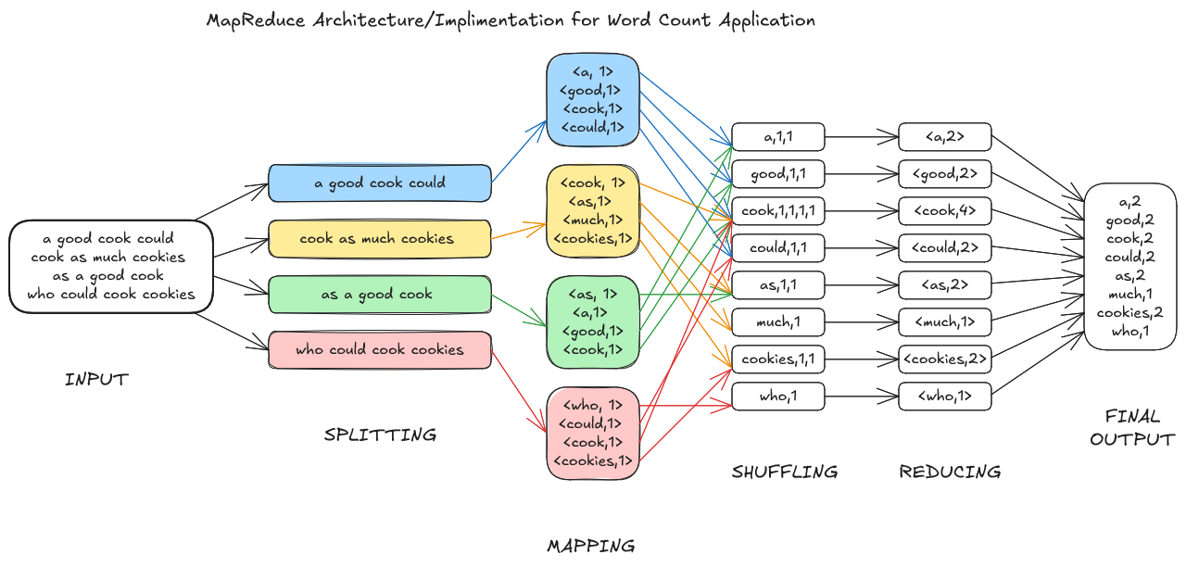

YARN

### ****Hadoop YARN (Yet Another Resource Negotiator)****

**YARN** is a core component of Hadoop 2.0 and later versions that addresses the limitations of the original **MapReduce 1 (MR1)** framework. It provides a more efficient way to **manage cluster resources** and allows **multiple data-processing engines** (MapReduce, Spark, etc.) to run on the same Hadoop cluster, enhancing performance, scalability, and flexibility.

### ****1. YARN Introduced in Hadoop 2.0****

* **Hadoop YARN** was introduced in **Hadoop 2.x** to overcome the **limitations of the MapReduce 1 (MR1)** framework.
* It **decouples resource management** and **job scheduling/monitoring**, allowing Hadoop to **support multiple applications beyond MapReduce**, such as **Apache Spark, Hive, Flink**, etc.

### ****2. Separation of Resource Management and Processing Layer (MR1 vs. YARN)****

In **MR1**, the **JobTracker** was responsible for **both job scheduling/monitoring** and **resource management**, which caused **performance bottlenecks** and made the system hard to scale.

* **MR1 Responsibilities:**
  + **Job Execution:** Coordinate map and reduce tasks.
  + **Job Scheduling:** Assign tasks to available TaskTrackers.
  + **Job Monitoring:** Track task progress and handle failures.
  + **Resource Management:** Allocate resources (CPU, memory) for tasks.

With **YARN**, these tasks are **split into separate components**:

* **Resource Management:** Handled by the **ResourceManager**.
* **Job Scheduling and Monitoring:** Delegated to **ApplicationMaster** per application.

### ****3. Motivation for MapReduce Version 2 and MRV1 Limitations****

**3.1 Performance Bottlenecks in MR1:**

* **JobTracker Overload:**
  + In MR1, the **JobTracker** was responsible for **both scheduling jobs and monitoring resources**. This dual responsibility caused **overhead**, leading to slower performance as the number of jobs increased.
* **Single Point of Failure:**
  + If the **JobTracker** failed, the entire system would stop, affecting all running and scheduled jobs.

**3.2 Scalability Issues in MR1:**

* **Limited to MapReduce:**
  + MR1 was **tightly coupled** to the MapReduce engine, meaning it couldn’t support other data processing engines like **Spark or Hive**.
* **Cluster Utilization Issues:**
  + MR1 allocated resources based on **fixed slots** for Map and Reduce tasks, which sometimes led to **underutilization** when certain task types were not needed.

### ****4. YARN Architecture Overview****

YARN introduces a **flexible and scalable architecture** by splitting resource management and application management.

* **Key Features of YARN Architecture:**
  + **Centralized Resource Manager**: Manages the cluster’s resources.
  + **Application-Specific ApplicationMaster**: Each job/application gets its own ApplicationMaster to schedule and monitor tasks.
  + **NodeManagers**: Manage resources and tasks on individual nodes.
  + **Data Locality Optimization**: YARN schedules tasks on nodes where the required data is already present, reducing network traffic.

### ****5. YARN Components****

**ResourceManager (Master Component):**

* + The **ResourceManager** is the **central authority** in a YARN cluster. It handles **resource allocation** and **scheduling** across the cluster.
  + **Responsibilities:**
    - **Accepts job requests** from clients.
    - Manages the **available resources** in the cluster.
    - Communicates with **ApplicationMasters** and **NodeManagers** to allocate resources.
  + **Components of ResourceManager:**
    - **Scheduler:** Allocates resources to applications based on policies (e.g., FIFO, Capacity, or Fair Scheduler).
    - **ApplicationsManager:** Manages application submissions and coordinates with ApplicationMasters for job status.

**NodeManager (Slave Component):**

* + **Runs on every node** in the cluster and reports to the ResourceManager.
  + **Manages local resources** (CPU, memory) and **launches tasks** as directed by the ApplicationMaster.
  + **Sends heartbeats** to the ResourceManager to report its status and availability.

**ApplicationMaster (Per-Application Component):**

* + Each job or application (e.g., MapReduce job) gets its own **ApplicationMaster**.
  + **Responsibilities:**
    - Negotiates resources with the ResourceManager.
    - **Monitors the status of tasks** and **handles task failures**.
    - It is **application-specific**, meaning different engines (MapReduce, Spark) can have different ApplicationMasters.

**Containers:**

* + **Containers** are the **basic units of computation** in YARN. A container encapsulates a specific amount of **CPU and memory** allocated to a task.
  + **Tasks are executed within containers**, managed by the NodeManager.

### ****6. YARN and MapReduce Master-Slave Architecture (MapReduce v2)****

**ResourceManager (Master Node):**

* + Oversees the entire cluster’s resources and allocates them to ApplicationMasters.

**NodeManagers (Slave Nodes):**

* + Manage the containers on each machine and ensure tasks are executed as requested by the ApplicationMaster.

**ApplicationMaster (Per Job):**

* + Manages the **execution of the job** by scheduling map and reduce tasks into containers on the NodeManagers.

This **master-slave architecture** ensures better resource management and flexibility in running multiple data processing engines.

### ****7. Workflow in YARN (WordCount Example)****

**Job Submission:**

* + The client submits a **MapReduce job** to the ResourceManager.

**ApplicationMaster Launch:**

* + ResourceManager allocates a container to launch the **ApplicationMaster** for the job.

**Task Scheduling:**

* + ApplicationMaster requests containers from NodeManagers for **map and reduce tasks**.

**Task Execution:**

* + NodeManagers execute the tasks inside containers and send status updates to the ApplicationMaster.

**Monitoring and Completion:**

* + ApplicationMaster monitors task progress and informs the ResourceManager when the job is completed.

### ****8. Benefits of YARN (MRV2):****

**Better Scalability:**

* + YARN can handle **thousands of nodes and concurrent applications** more efficiently than MR1.

**Support for Multiple Frameworks:**

* + YARN allows other engines like **Spark, Hive, and Flink** to run on Hadoop, not just MapReduce.

**Improved Resource Utilization:**

* + Resources are allocated **dynamically** (via containers) rather than in fixed slots, reducing underutilization.

**Fault Tolerance:**

* + If an **ApplicationMaster or NodeManager fails**, only the corresponding application is affected, and it can be restarted without affecting the whole cluster.

### ****9. Limitations of YARN:****

**Complexity:**

* + YARN is more complex to configure and manage than MR1 because of its decentralized architecture.

**Overhead:**

* + Running separate **ApplicationMasters** for each application adds some overhead.

**Security Challenges:**

* + Managing security and resource isolation between applications is more complicated.

### ****Conclusion:****

YARN provides a **more scalable, flexible, and efficient** framework for resource management in Hadoop. By separating the **resource management layer** from the **processing layer**, YARN overcomes the limitations of MapReduce 1, allowing Hadoop to run not just MapReduce but also other processing engines like Spark, Hive, and Flink, thus making it a **general-purpose data platform**.

